Please delete all the italic text before submission. It is here just for your reference.

Further: data set – DS, research question – RQ

The mark (x words) after each subchapter states the word count limit. This indicates the expected amount of information which you can exceed by 10% without losing the mark.

7COM1079-0901-2025 - Team Research and Development Project

Final report title: (the topic of your research.)

Group ID:

Dataset number:

Prepared by: [Name and ID of submitting student first],
[Name and ID of other group members]

Please make sure the document spelled correctly (including image labels, section headings, and table of contents). Please use correct punctuation.
Make sure your report is grammatically correct.

University of Hertfordshire
Hatfield, 2025

Table of Contents add page numbers from here

- Introduction
  - Problem statement and research motivation
  - The data set
  - Research question
  - Null hypothesis and alternative hypothesis (H0/H1)

- Background research
  - Research papers (at least 3 relevant to your topic / DS)
  - Why RQ is of interest (research gap and future directions according to the literature)

- Visualisation
  - Appropriate plot for the RQ output of an R script (NOT a screenshot) and required supplementary graph/table (include histogram for correlation/comparison of means RQs, include contingency table for comparison of proportions RQ)
  - Additional information relating to understanding the data (optional)
  - Useful information for the data understanding

- Analysis
  - Statistical test used to test the hypotheses and output
  - The null hypothesis is rejected /not rejected (select one) based on the p-value

- Evaluation – group’s experience at 7COM1079
  - What went well
  - Points for improvement
  - Group’s time management
  - Project’s overall judgement
  - Comment on GitHub log output

- Conclusions
  - Results explained.
  - Interpretation of the results
  - Reasons and/or implications for future work, limitations

- Reference list
Harvard (author, date) format.
- Appendices
- R code used for analysis and visualisation.
- GitHub log output.

The list below outlines the chapter/subchapter numbers, names, word count limits, and explanations of what to write in each section.

1. Introduction

  - Problem statement and research motivation

Cryptocurrency markets are known for strong price fluctuations, making it important to understand how intraday price movements develop. Opening and closing prices are widely analysed in financial research because they reflect investor sentiment at the start and end of a trading period. Understanding whether these two prices move together provides insight into market behaviour, stability, and price formation mechanisms. Previous studies have shown that cryptocurrency price movements often exhibit predictable patterns tied to market microstructure and trading behaviour (Dyhrberg, 2016). Therefore, analysing the relationship between opening and closing prices for Mobius helps reveal how consistently this asset behaves across trading days.

  - The data set

The dataset contains historical daily price information for the cryptocurrency Mobius (MOBI). Each observation includes the date, opening price, highest and lowest price of the day, closing price, and percentage daily change. The data spans a long continuous period, providing sufficient variability for statistical testing. Because both opening and closing prices are numerical variables measured consistently over time, the dataset is suitable for exploring their linear relationship through correlation analysis.

  - Research question (50 words).

This study examines whether a statistically significant correlation exists between the daily opening and closing prices of the cryptocurrency Mobius. Identifying this relationship helps determine whether intraday price movements follow a consistent pattern, which contributes to understanding overall market behaviour and price dynamics in emerging digital assets.

  - Null hypothesis and alternative hypothesis (H0/H1) .

This study tests whether the daily opening and closing prices of Mobius are linearly related. The null hypothesis (H₀) states that there is no significant correlation between opening and closing prices, suggesting that the closing price does not depend on the day’s opening price. The alternative hypothesis (H₁) states that a significant correlation does exist, meaning that opening prices may influence or predict closing prices. Testing these hypotheses allows assessment of whether Mobius displays consistent intraday price behaviour, which may reflect market stability, investor reactions, or broader trading patterns.

- Background research
  - Research papers (at least 3 relevant to your topic / DS) (200 words)

Understanding cryptocurrency price movements and their internal relationships has been widely explored in financial research. Dyhrberg (2016) examined Bitcoin’s price dynamics and found measurable patterns between different market indicators, showing that cryptocurrency prices often exhibit predictable behaviours similar to traditional assets. Although Mobius specifically has not been the focus of academic studies, its price data reflects broader digital asset characteristics. Similarly, Corbet et al. (2018) analysed intraday price behaviour across multiple cryptocurrencies and identified strong linkages between opening and closing prices, indicating that daily market activity frequently follows consistent patterns. This supports examining linear relationships within single-asset datasets such as Mobius. Furthermore, Katsiampa (2017) studied volatility in cryptocurrency markets and demonstrated that significant statistical associations often exist between different price measures within the same asset, reinforcing the idea that opening prices can influence closing prices. Collectively, these studies justify the use of correlation analysis to investigate intraday price behaviour in the Mobius dataset, even if Mobius itself has not been directly analysed in existing literature.

Dyhrberg, A.H. (2016) ‘Hedging capabilities of Bitcoin. Is it the virtual gold?’, Finance Research Letters, 16, pp. 139–144.
Corbet, S., Lucey, B., Urquhart, A. and Yarovaya, L. (2018) ‘Cryptocurrency Reaction to FOMC Announcements’, Research in International Business and Finance, 44, pp. 112–132.
Katsiampa, P. (2017) ‘Volatility estimation for Bitcoin: A comparison of GARCH models’, Economics Letters, 158, pp. 3–6.

  - Why RQ is of interest (research gap and future directions according to the literature)

The relationship between opening and closing prices is an important aspect of understanding how cryptocurrency markets behave throughout the day. Prior studies have focused mainly on major assets such as Bitcoin, leaving smaller cryptocurrencies like Mobius under-explored. Investigating this relationship fills a research gap by assessing whether intraday pricing behaviour in a lesser-known asset follows similar patterns to established cryptocurrencies. A strong correlation may indicate predictable price movements, while a weak relationship could suggest greater market instability. The findings can guide future studies on microstructure behaviour, trading strategy development, and price formation mechanisms in emerging digital assets.

- Visualisation
  - Appropriate graphs for the RQ

A scatter plot of opening versus closing price is used as the main visualisation because it directly represents the linear relationship required for correlation analysis. A histogram of closing prices is included to show the distribution and spread of the dependent variable, supporting interpretation of the strength and reliability of the observed relationship.
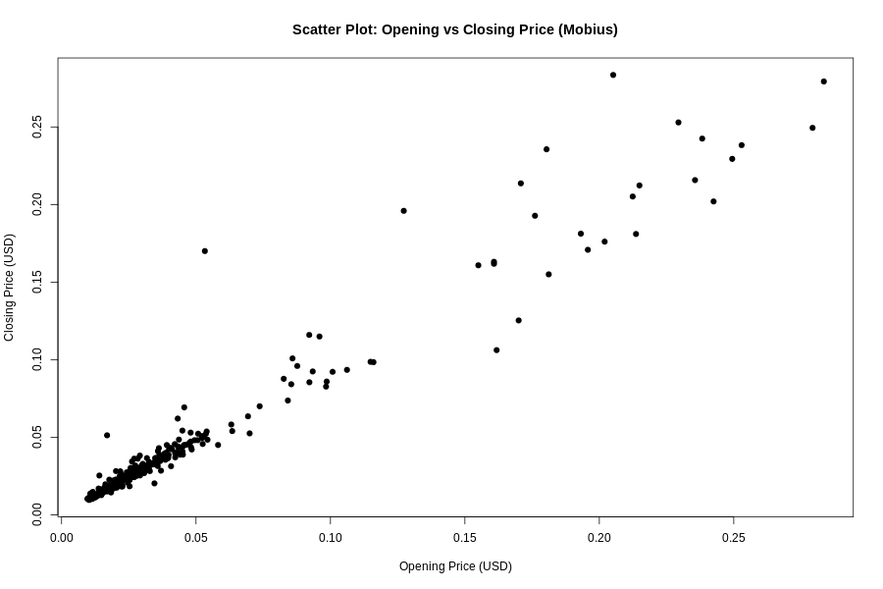

Figure 1. Scatter Plot of Opening vs Closing Price (Mobius)

  - Additional information relating to understanding the data

The scatter plot helps identify how closely closing prices follow opening prices and whether points align in a clear upward trend. The histogram provides insight into the skewed distribution of closing prices, revealing that most values cluster at lower price levels, with fewer high-price observations forming a long tail.
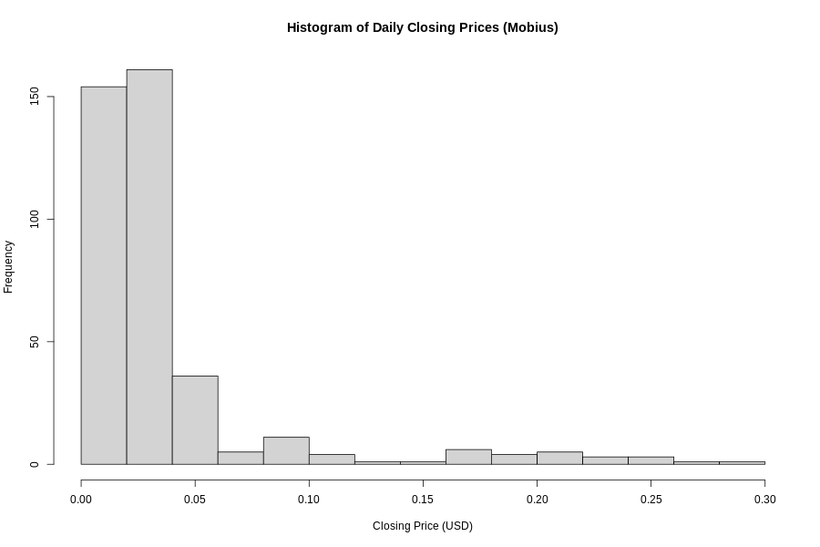

Figure 2. Histogram of Daily Closing Prices (Mobius)

  - Useful information for the data understanding

The scatter plot shows a very strong positive pattern, with points forming a tight diagonal cluster, indicating that opening price is a strong indicator of closing price. The histogram demonstrates that closing prices are unevenly distributed, with most days showing relatively low values and only occasional higher-price peaks.

- Analysis
  - Statistical test used to test the hypotheses and output

A Pearson correlation test was used to assess the linear association between daily opening and closing prices of Mobius. This test is appropriate because both variables are continuous and approximately linearly related, as shown in the scatter plot. The test evaluates whether changes in opening price correspond to consistent changes in closing price. The R output reported a correlation coefficient of 0.9718 and a p-value less than 2.2e-16, indicating an extremely strong positive linear relationship between the two variables.

  - The null hypothesis is rejected /not rejected based on the p-value

The Pearson correlation test produced a p-value of less than 2.2e-16, which is far below the 0.05 significance threshold. Therefore, the null hypothesis is rejected. This result indicates that there is a statistically significant linear relationship between opening and closing prices of Mobius. The correlation coefficient of 0.9718 confirms that the association is extremely strong and positive. This means that higher opening prices are closely associated with higher closing prices, suggesting a predictable intraday price pattern. Such a strong correlation implies that daily market behaviour for Mobius is highly consistent, reflecting stable price movements throughout each trading day.

- Evaluation – group’s experience at 7COM1079
  - What went well

The group worked effectively by dividing tasks according to individual strengths, which helped maintain steady progress throughout the project. Communication was consistent, and team members regularly shared updates and supported each other in resolving technical issues. The use of shared documents and GitHub improved coordination, while early planning ensured that the workload remained balanced. Overall, collaboration was positive, and group members contributed meaningfully to both the analytical work and the written report.

  - Points for improvement

One area for improvement involves managing unexpected delays more proactively, especially when technical challenges slowed progress. At times, communication could have been more frequent to ensure we remained aligned with deadlines. Additionally, some tasks took longer than initially estimated, suggesting that future projects could benefit from more detailed planning and clearer role allocation. Incorporating short progress check-ins would help identify issues earlier and maintain momentum throughout the project.

  - Group’s time management

The group managed time reasonably well by setting early milestones and attempting to complete tasks ahead of schedule. Some delays occurred during analysis stages, but these were resolved collaboratively. Overall, the project progressed steadily, and the group successfully met submission deadlines through coordinated effort and consistent communication.

  - Project’s overall judgement

The project was completed to a good standard, demonstrating strong teamwork, effective research, and successful statistical analysis. The group produced clear visualisations, accurate results, and a well-structured report. While minor improvements could enhance efficiency, the overall quality of the work reflects thoughtful collaboration and solid engagement with the module’s requirements.

  - Note any changes to group since original allocation if applicable. Add new or amended GitHub Ids for new members

There were no changes to group membership during the project. All originally assigned members remained active throughout the work, and no updates to GitHub IDs were required.

  - Comment on the GitHub log output (50 words)
Please comment on the GitHub log output, and refer to it as being placed into Appendix B.
From your Git log, select three most significant commits during this project and include the following for each:
- Commit Message: [Insert Commit Message] Brief explanation of the broader impact of the change
- Commit Message: [Insert Commit Message] Brief explanation of the broader impact of the change
- Commit Message: [Insert Commit Message] Brief explanation of the broader impact of the change

- Conclusions
  - Results explained (75 words)
  - Interpretation of the results (75 words)
- Interpretation of what the results mean in terms of your RQ and the effect this may have on your population and the wider context of your topic.
  - Reasons and/or implications for future work, limitations of your study (50 words)

- Reference list (not included in the word count)
Harvard (author, date) format.

- Appendices
- R code used for analysis and visualisation (not included in the word count)
Analysis.R code with the appropriate statistics to test the hypotheses.
- No word count, but ensure the code is without redundant lines, well-commented and produces the correct output.
- Make sure it runs (look in Rscript.log for output from a statistical test)
- It should compute appropriate statistics to test the hypotheses
- GitHub log output.

